Part 4, Joins

Join Types

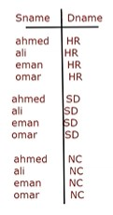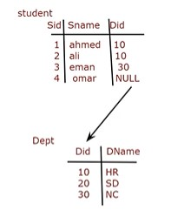

* Cross Join
* Cartesian Product
  + - Select Sname, Dname

From Student **,** Dept

* + - Select Sname, Dname

From Student **Cross Join** Dept

* 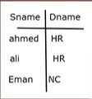Inner Join
* Equi Join (PK = FK)
  + - Select Sname, Dname

From Student , Dept

Where Dept.Did = Student.Did

* + - Select Sname, Dname

From Student S , Dept D

Where D.Did = S.Did

* + - Select Sname, Dname

From Student S Inner join Dept D

on D.Did = S.Did

* 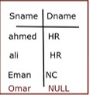Outer Join
* Left Outer Join (4 rows)
  + - Select Sname, Dname

From Student S Left Outer Join Dept D

on D.Did = S.Did

* 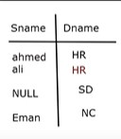Right Outer Join (4 rows)
  + - Select Sname, Dname

From Student S Right Outer Join Dept D

on D.Did = S.Did

* 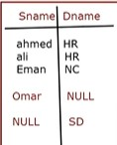Full Outer Join (5 rows)
  + - Select Sname, Dname

From Student S Full Outer Join Dept D

on D.Did = S.Did

* Self Join
* When there is a Self – Relationship.
  + - Select X.Ename as Emp , Y. Ename as SuperName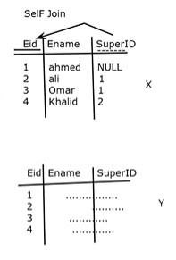 From Employee X , Employee Y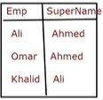

Where Y.Eid = X.SuperID